M.Sc. Information Security Lab Assignment - Practical
Name: Harshit Kumar More
Roll No: 16

Task1: Google Dorking(Information Gathering)
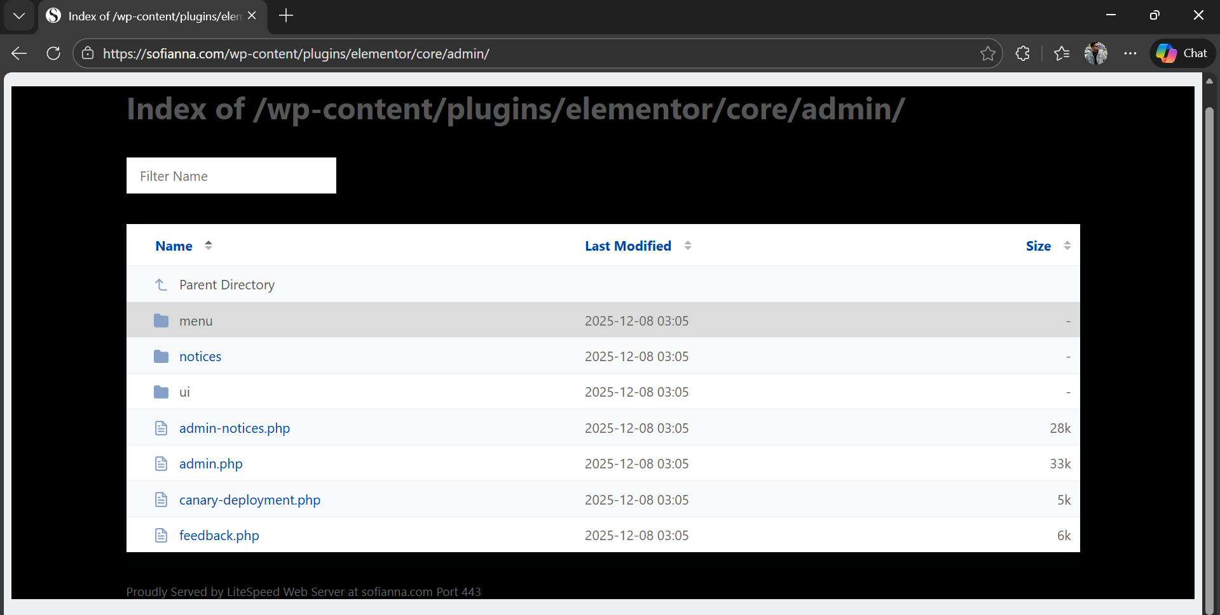
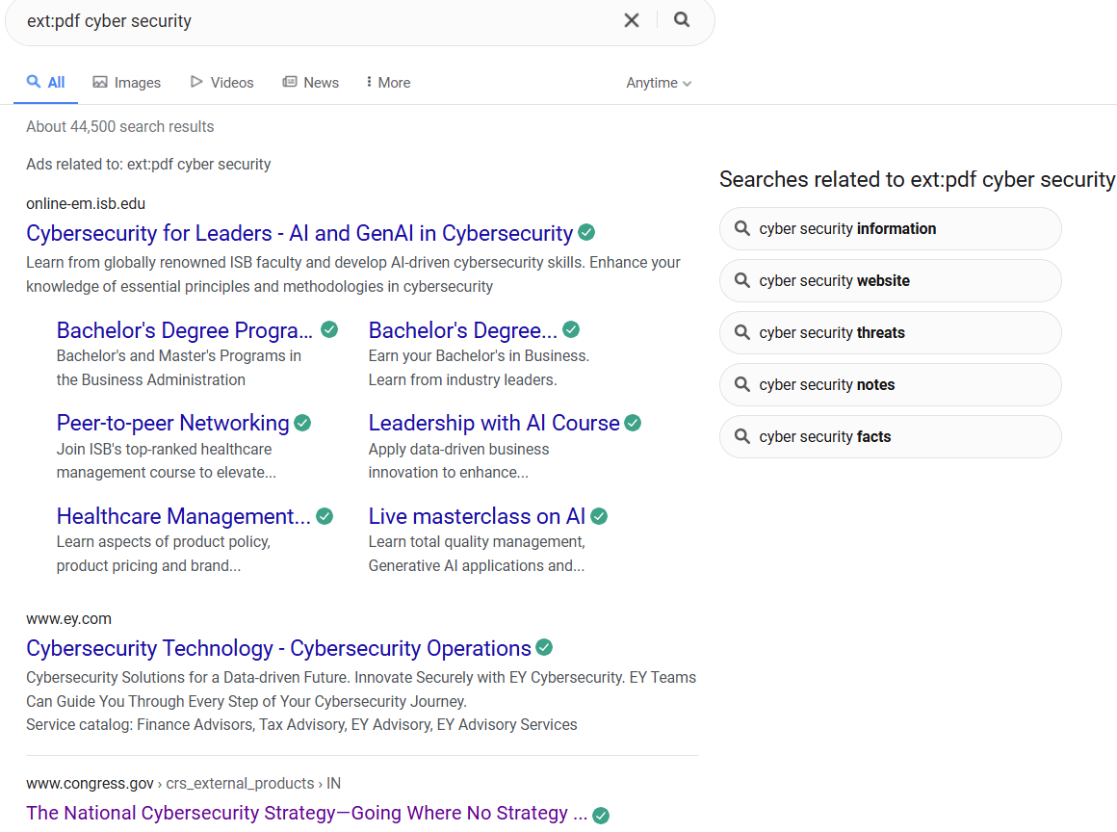
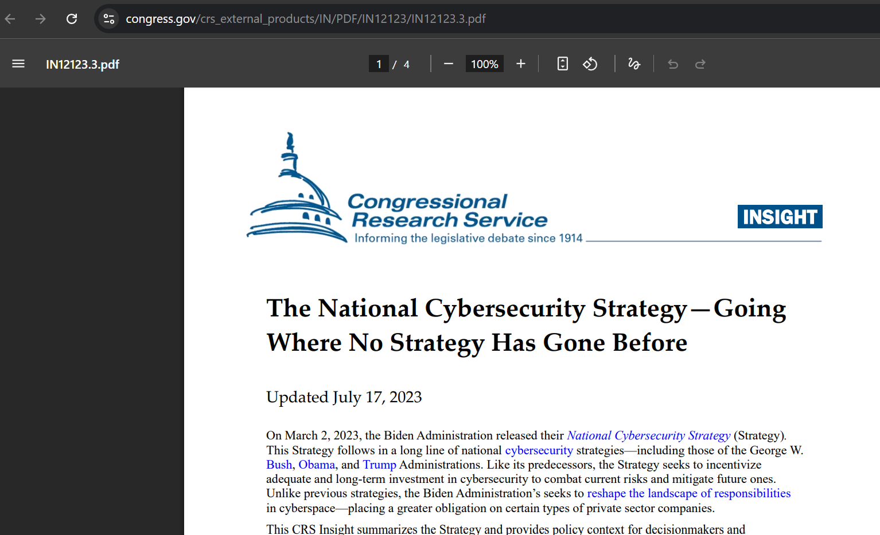
Observations
- inurl:login
The search result shows websites that have login pages in their URL. Some of these login pages are very basic and may not use strong security measures. Such pages can be vulnerable to brute-force or password-guessing attacks if not properly protected.
- ext:pdf cyber security
This query returns publicly available PDF files related to cybersecurity, such as research papers, reports, and training materials. In some cases, these documents may contain sensitive or internal information that should not be publicly accessible, which can lead to security risks.

Security Risks:
- Exposed login pages that can easily be compromised using brute-force attack
- Sensitive documents leakages that may have information related to employees or technologies used in their system that may be used for targeted attacks later.
Security Threats:
- Exposed login pages can be attacked using brute-force and credential-stuffing techniques.
- Weak authentication may lead to unauthorized access to systems and data.
- Publicly available PDF documents can leak sensitive or internal information.
- Attackers can use this information for reconnaissance and social-engineering attacks

Task 2: Phishing Website Detection

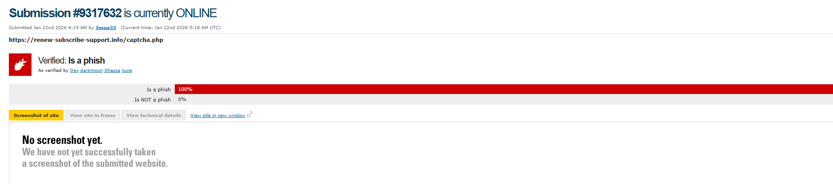

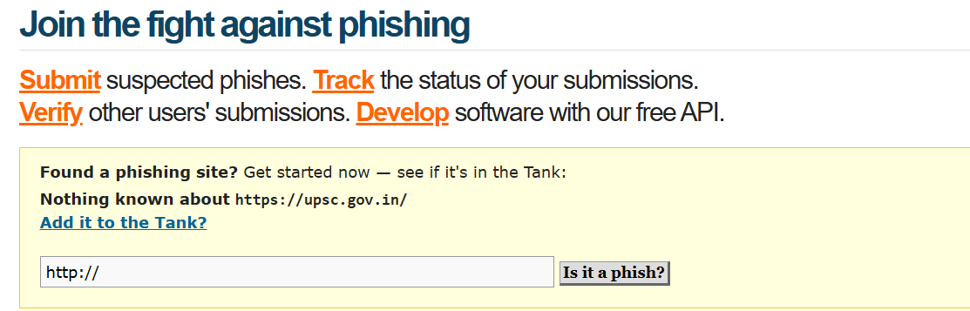


Indicators to Identify Phishing
- Suspicious sender email address
The email address looks fake or slightly misspelled compared to the official domain.
- Urgent or threatening language
Messages create panic, such as “act now,” “account will be blocked,” or “verify immediately.”
- Unusual links or URLs
Links do not match the official website or use shortened/modified URLs.
- Unexpected attachments
Attachments (PDF, ZIP, EXE) sent without prior communication may contain malware.
- Requests for sensitive information
Legitimate organizations do not ask for passwords, OTPs, or bank details via email.
- Poor grammar and spelling mistakes
Many phishing messages contain noticeable language errors.
- Mismatch between link text and actual link
The visible text shows a trusted site, but the actual link leads elsewhere.

Task 3: Whois Lookup (Domain Information)
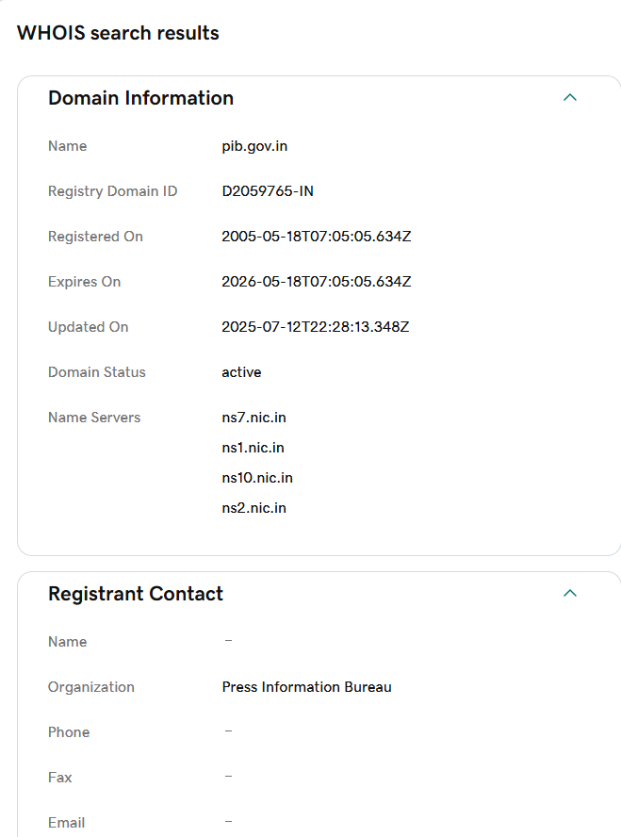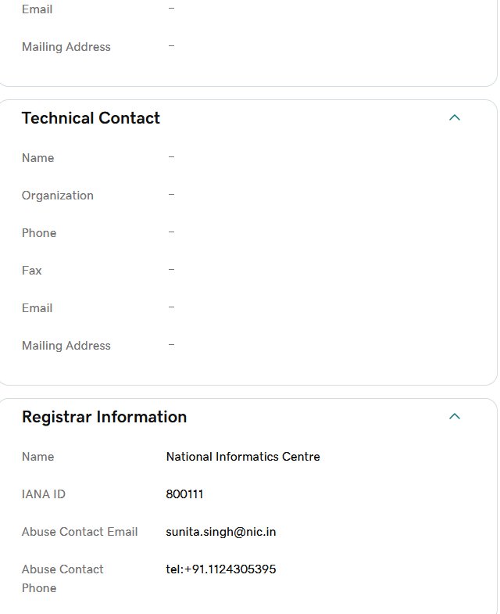
How can attackers misuse this information?
- Reconnaissance: Such as organization details, server details, service providers, etc.
- Social Engineering: Used to create fake but believable emails to compromise users
- Target attacks: by knowing IP Ranges it is easy to scan network and target servers and infrastructures
- Domain Takeover attempts: Expired or misconfigured domains can easily be targeted and hijacking attempts can be done.

Task 4: Network Scanning using NMAP

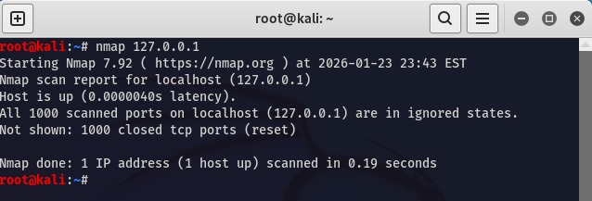
Observations
After performing an Nmap scan on 127.0.0.1 (localhost), the results revealed several open ports along with the services running on them. The scan also showed the status of each port, such as open, closed, or filtered, indicating how the system responds to network requests.
Some commonly identified ports were:
- Port 22 – SSH
- Port 80 – HTTP
- Port 443 – HTTPS
Ports listed in ignored states (as shown in scan statistics) are those that do not respond to probe requests. These ports are usually filtered or blocked by firewall rules, indicating that security mechanisms are in place. However, advanced scanning tools may still attempt to analyze such ports for potential weaknesses.

Security Risks of Open Ports
- Unauthorized Access: Open ports may allow attackers to access services remotely if authentication and security controls are weak.
- Service Exploitation: Vulnerable services running on open ports can be exploited using known vulnerabilities and attack tools.
- Brute-force Attacks: Services like SSH are common targets for brute-force login attempts.
- Information Disclosure: Open services may expose software versions and configurations, helping attackers plan attacks.
- Expanded Attack Surface: A higher number of open ports increases the chances of successful attacks.

Summary and Conclusion
In conclusion, tools like Nmap provide basic yet powerful insights into system and network exposure. They help identify open ports, running services, and possible security risks. Understanding this information is important for detecting vulnerabilities, preventing cyber attacks, and strengthening system and network security through proper configuration and security measures.

